DATA VISUALIZATION LAB OUTPUTS:

PYTHON PROGRAM OUTPUTS:
LINE CHART: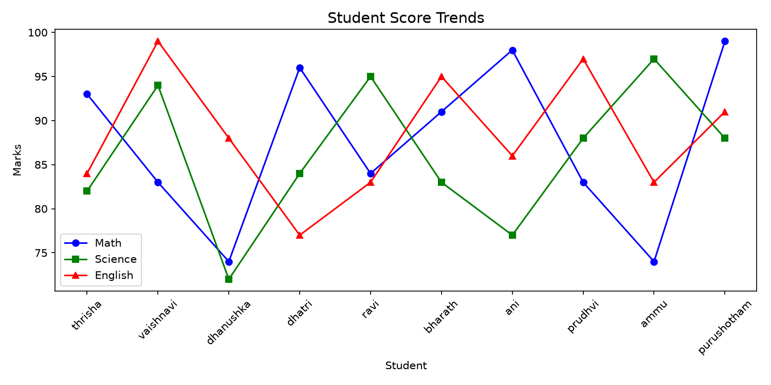
BAR CHART:
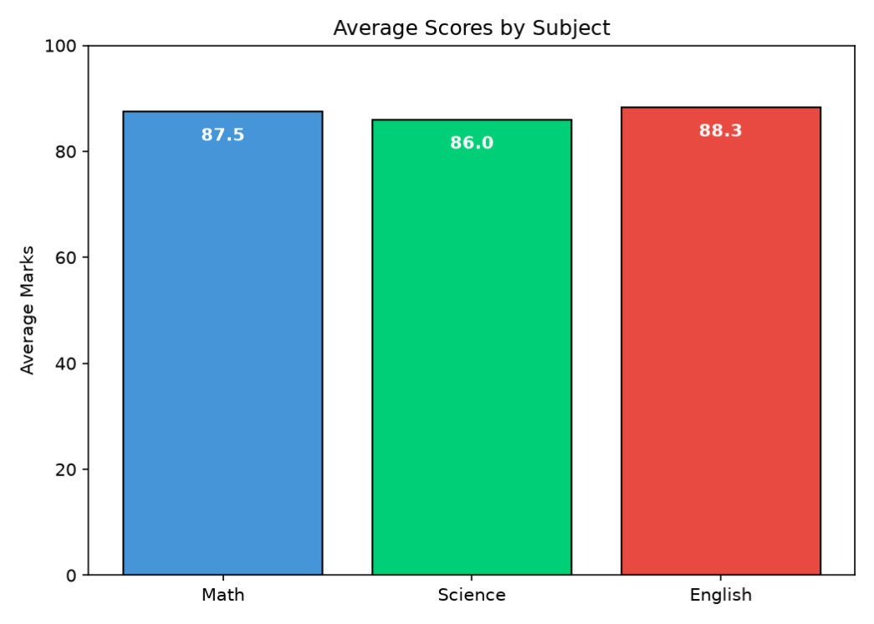
HISTOGRAM:
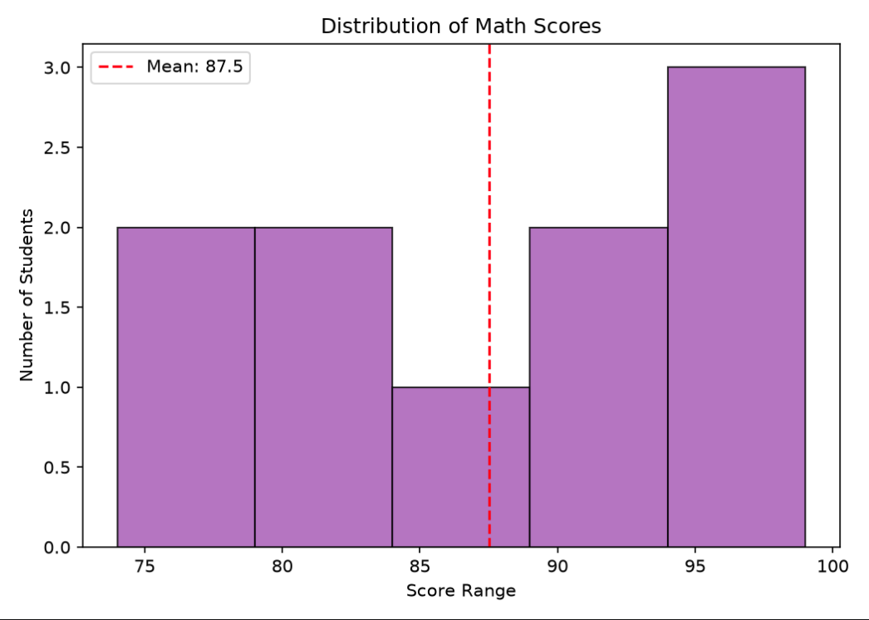
SCATTER PLOT:
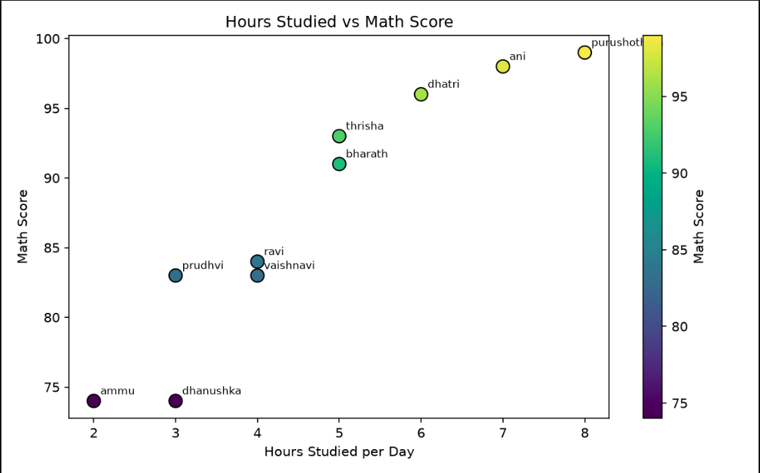
CORRELATION HEATMAP:
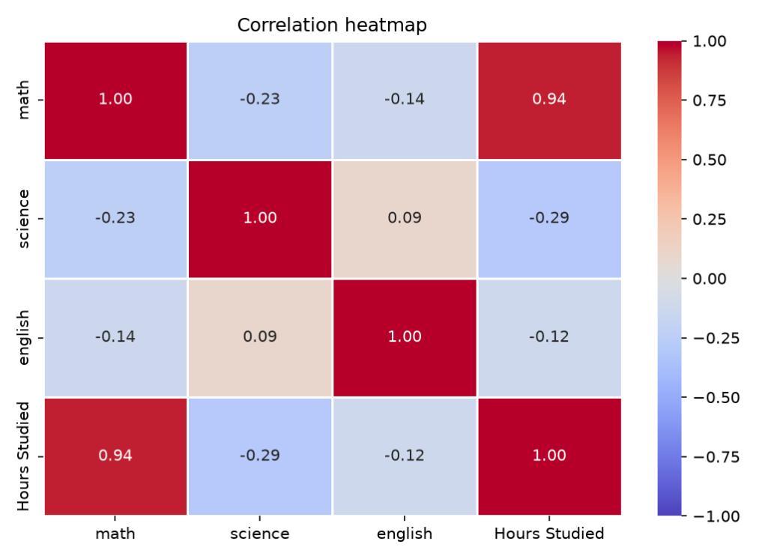
BOXPLOT:
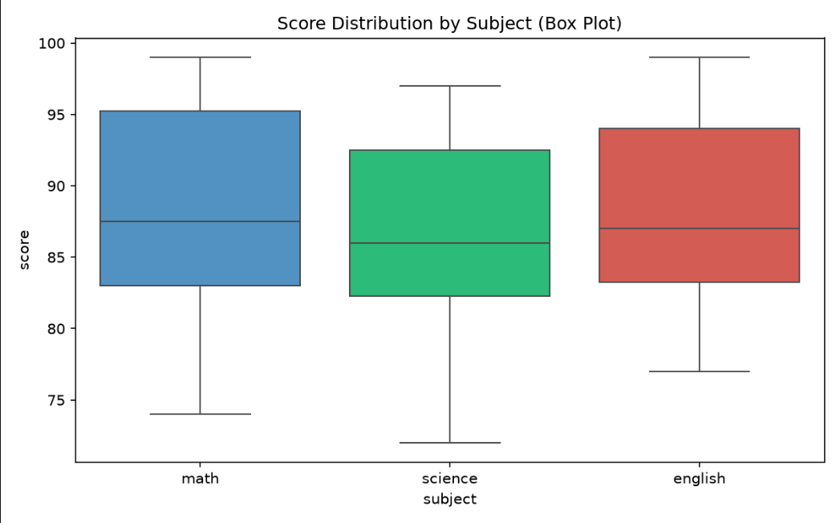
R PROGRAM OUTPUTS:
BAR CHART:
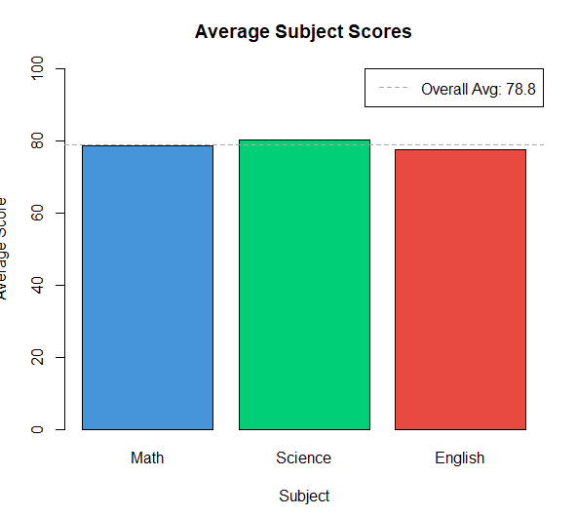
LINE CHART:
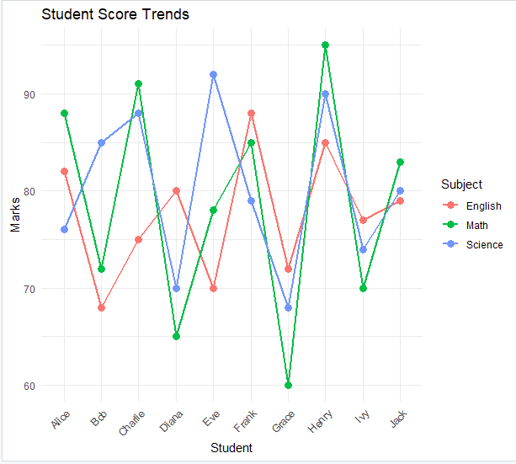
HISTOGRAM:
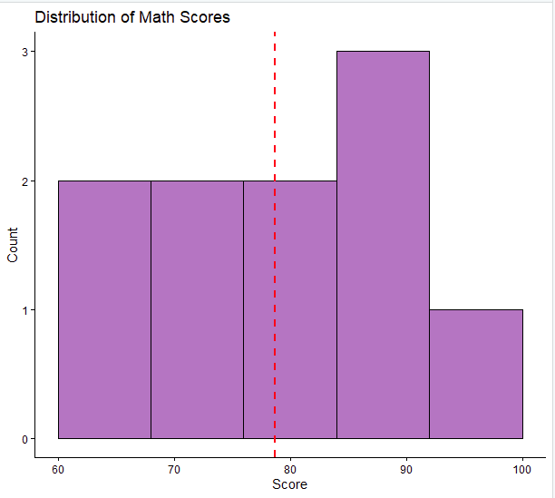
BOX PLOT:
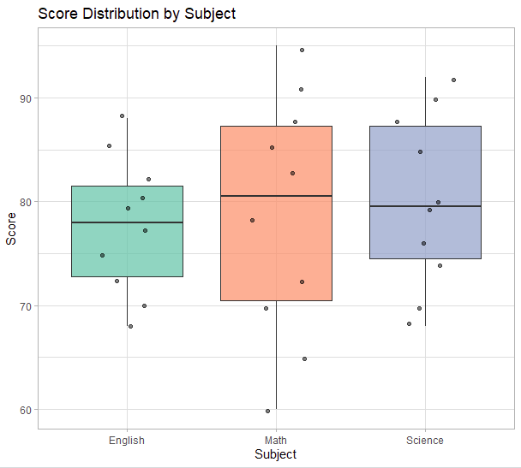
SCATTER PLOT:
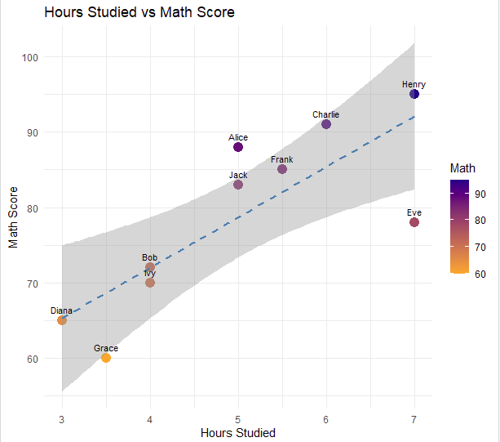
GROUPED BAR CHART:
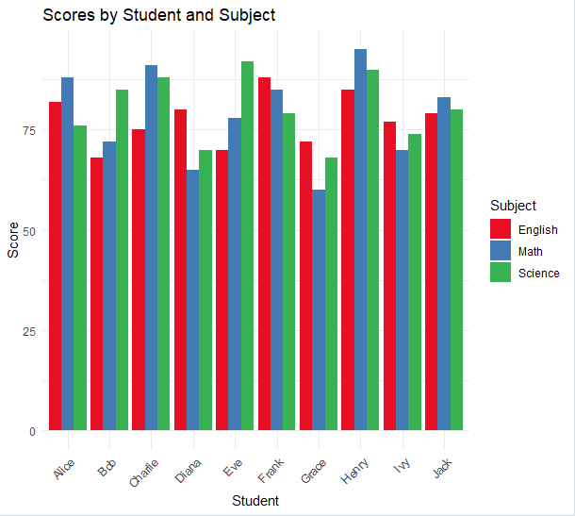
PIE CHART:


